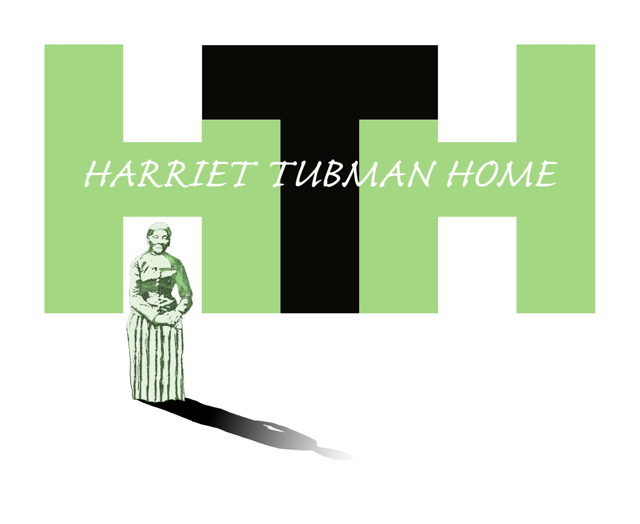180 South Street, Auburn, New York 13021

(315) 252-2081, Telephone (315) 252-2570, Fax

Report

to the

Connectional Council

African Methodist Episcopal Zion Church

Orlando, Florida

July 10-12, 2019

The Right Reverend Dennis V. Proctor, Chairman

PROGRESS REPORT

Visitation

The Harriet Tubman National Historical Park has more than doubled its visitors prior to park establishment in 2017, from 9,000 to 24,000 annual visitors. HTH has seasonal NPS Park Ranger support May - September and on an as needed basis throughout the year to assist with the increased demand.

The additional manpower during high volume visitation has increased the capacity of the HTH. In 2019, NPS was able to assign one Park Ranger to the HTHNP and Auburn. However, HTH remains constrained since it cannot receive additional Ranger support until the Cooperation Agreement is executed. The local NPS staff is committed to assisting as much as possible. For example, NPS kept the park open on Sunday during the warm weather months in 2018. In addition, NPS took on the responsibility for mowing the grass and snow removal, to provide some measure of relief for those items in the HTH budget. December 2018 through January 2019, the public and NPS saw the value of having an engaged private partner as the HTH kept the Tubman Park open to the public and clean during the government shutdown. See Attachment A - 2018 Visitation Report

Tubman Brick Residence

The HTH has spent close to 400K in the restoration of the Tubman Brick Residence, considered by many as the crown jewel of the Underground Railroad Movement. NPS is working on the Historic Structures Report of the Park. The brick Residence is approximately 50% complete, HTH is working on having NPS complete the restoration as a matter of priority, as soon as the Cooperation Agreement between HTH and NPS is executed and more importantly, the remaining preservation construction requires no additional funding from HTH.

PLEASE NOTE: The lack of a passed budget, which means NPS continues to operate with a Continuing Resolution, affects the HTH advocacy for

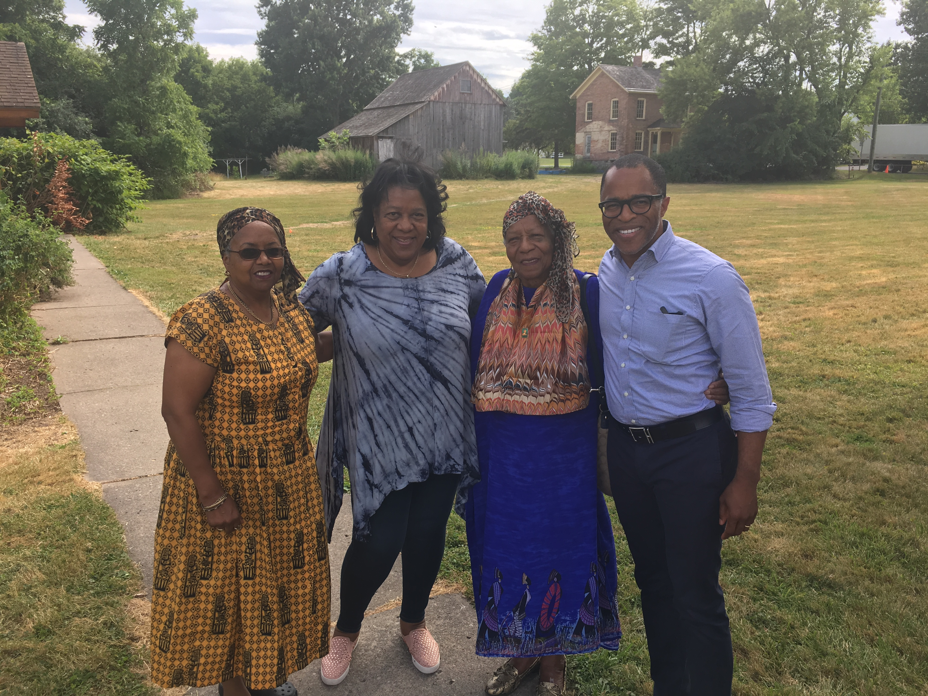
funding of the park, as discussed in the park legislation. There are no new

monies coming into NPS until a new budget is passed.

Faith and Politics Institute

Rep. Carolyn Maloney, Rep. Tom Reid and Rep. John Katko led the delegation of Smithsonian staff, Capital Hill staff and corporate supporters through Central New York to learn the history of the abolitionist movement. Jonathan Capehart, Washington Post journalist and MSNBC contributor chronicled the pilgrimage which featured the Harriet Tubman Home. FPI is in the process of organizing a 2020 pilgrimage back to Tubman, which is scheduled to include FPI Chair Emeritus, Rep. John Lewis and House Speaker, Nancy Pelosi.

Quest for Freedom Award and the CBC Prayer Breakfast and the $20 Banknote

Bishop Dennis V. Proctor honored Rep. Elijah E. Cummings with the Harriet Tubman Quest for Freedom Award at the Faith Leaders Roundtable of the Congressional Black Caucus Legislative Forum. This event attended by HTH Board members demonstrated the importance of board members as brand ambassadors. HTH thanks Bishop Proctor for his foresight in honoring Rep. Cummings as well as Rep. John Katko. Rep. Katko (who received the Quest for Freedom Award at the 2018 Pilgrimage) and Rep.

Cummings, again have worked in a bipartisan manner in sponsoring legislation to place Harriet Tubman on the $20 banknote by December 2020. They were joined by 15 co-sponsors. There are a number of bills in the U.S. Senate as well to address getting Tubman on the $20 banknote while Sen. Charles Schumer has called for a full investigation into the delay by the U.S. Treasury Inspector General.

Funding

The HTH applied for and received funding from the National Park Foundation in the amount of $180,000 to be paid in three installments. The purpose of the funds is to assist the HTH with the anticipated legal fees attendant to the processes in completing the Conservation and

Preservation Easement. This NPF grant agreement has been amended by $5,800 to cover the cost for an appraisal of the 31.05 acres at 180 South

Street. $150,000of the grant is restricted. It will cover the legal work involved in crafting two required petitions to the New York State Attorney General. $30,000, is unrestricted, to the HTH for grant administration.

A second grant to support financial literacy workshops for students has been funded. The National Park Foundation has funded a small demonstration grant of $50,000. The HTH will serve as grant administrator and advisor on content. $7,500 will go to the HTH for serving in the aforementioned roles.

On July 5th the National Trust for Historic Preservation awarded the HTH $50,000 in support of board development and capacity building. In making this grant award the National Trust noted the following- “we received an exceptional response from 462 applicants from across the country, requesting nearly $40 million. The National Trust closely reviewed each letter of intent and selected 52 organizations to submit full grant applications, which were then reviewed by staff from both the National Trust and several noted African American history organizations. The National Trust thinks your work is extraordinary, and that’s why your organization was one of only 52 who made it to the final round of the National Grant Program. Upon review, the National Trust has selected 22 applicants into the 2019 cohort of grantees.” African American historic sites are now getting some recognition in the historic preservation space where the competition is robust and the funding is finite.

Conservation and Preservation Easement

The granting of an easement is a lynchpin to consummating the partnership between the HTH and the NPS as discussed in the federal legislation. More importantly the Cooperation Agreement which defines the operational, maintenance, preservation and financial support between HTH and NPS cannot be completed until the Conservation and Preservation Easement for the South Street property is approved and an order is issued by the New York State Supreme Court.

Completing the work on the Easement is expected to take approximately a year. NPS cannot order the appraisal of the property until all language in the Easement is approved by all parties.

Pilgrimage 2019 and 2020

The 2019 Harriet Tubman experienced for the first time, the previous, 2018 Speaker was invited back, The Rev. Dr. Frederick Douglass Haynes, III was heartedly received by all. Dr. Haynes’ subject, The Unstoppable Quest for Freedom left clergy and lay, alike, riveted. Harkening all to adapt Harriet’s spirit and “Come Through”. Dr. Haynes was instantaneously invited back again for 2020 - making it a three-peat. The entire weekend was dynamic with Jazz Vespers and a reception on Friday evening and the Rev. Dr. Melanie Miller leading the Harriet Tubman memorial at the Graveside ceremony.

The date for the 2020 Harriet Tubman Pilgrimage is May 30-31, 2020.

Naturalization Ceremony - Oath of Citizenship

The public facing activities and services continues to be a priority. For instance, from June - mid September the Park is open six days a week, including Sunday. On Thursday, August 8, 2019 the HTH will be the site for the Central New York Naturalization Ceremony. This is a significant occasion for the Tubman Park where we celebrate the life of the Free Harriet. The greater Syracuse area is the second largest refugee resettlement area in the United States. This promises to be a memorable moment in Tubman history-the Free Harriet welcoming new Americans on the property she was able to experience as a free person. Planning has begun. Judge Therese Dancks will administer the Oath.

During the year of Women’s Suffrage, 2020, the HTH is looking, again, to be considered for Naturalization ceremonies.

Profit and Loss and Balance Sheet 2018 of the Harriet Tubman Home are attached - See Attachment B

.

